Advertising Rates

Chola- Textile machine store is one of the main platform to buy and sell used machines of textile industries.

1. Gold Advertisement / Website Banner
Your banner Ad will appear on Home page with larger space

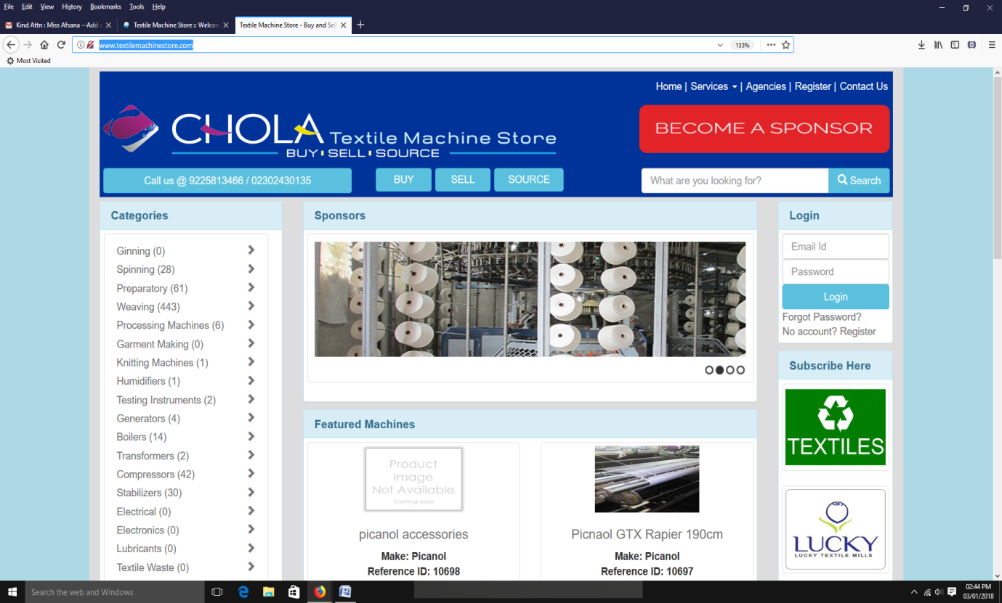
Gold Advertisement

Rates:
- Yearly :Rs. 1 lac
- Quarter : Rs. 30,000

Image pixel - 600 px *150 px

2. Silver Advertisement
Your banner Ad will appear on the top right corner of our website
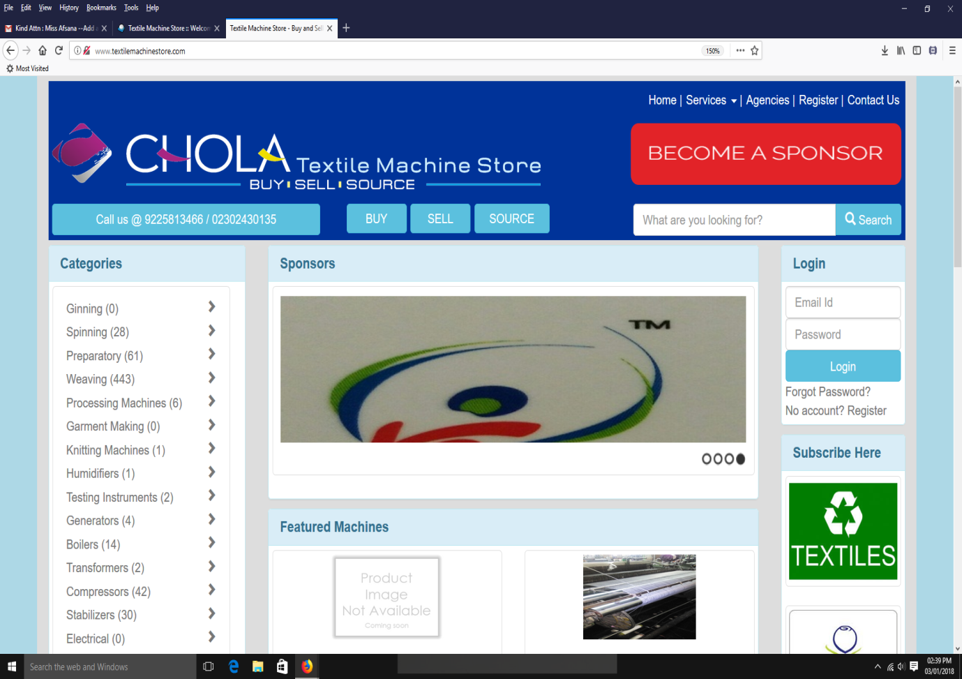
Silver Advertisement
Rates:
- Quarter : Rs. 15,000

Image pixel - 360 px *65 px

3. Bronze Advertisement
Your banner Ad will appear on right side of Home page and all the next pages

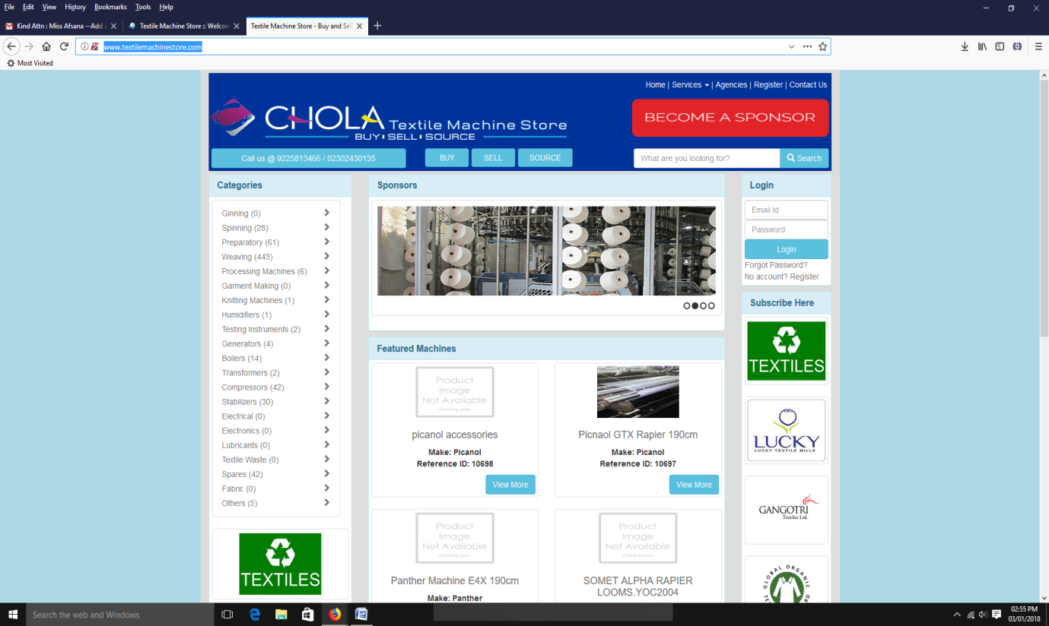
Bronze Advertisement

Rates:
- Quarter : Rs. 10,000

Image pixel - 120 px *120 px

4. Premium Seller for featured machines
Get more contacts and qualified leads for your products!
- Your products appear on the homepage of the website,
- They are displayed at top of search listings once posted.
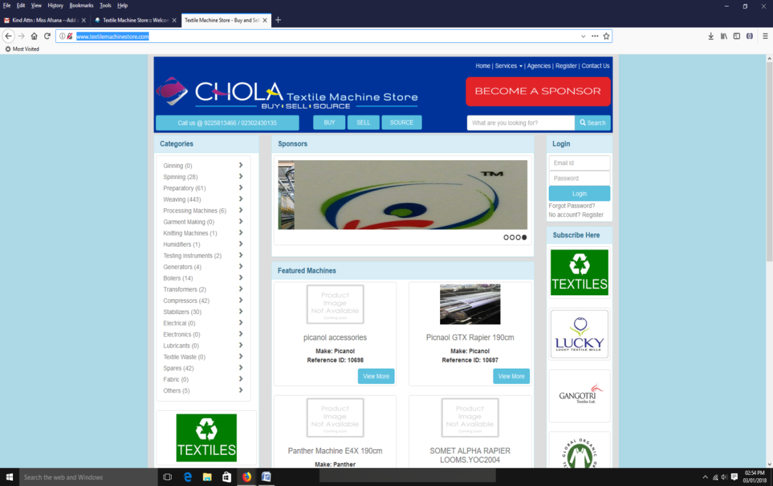
Featured machines

Rates
- Monthly : Rs. 10,000
- Quarterly : Rs. 25,000

5. Land for Rent/Sale Advertisement
- Monthly : Rs. 1,000
- Quarterly : Rs. 2,500

